Transformer Conversational

Chatbot Using Tensorflow 2.0

Gaurav Gurav

Department Of Computer Engineering

Pillai HOC College Of Engineering & Technology , Rasyani ,India

[gaurav1933gr@gmail.com](mailto:gaurav1933gr@gmail.com)

Kshitij Zunjaroa

Department Of Computer Engineering

Pillai HOC College Of Engineering & Technology , Rasyani ,India

[kshitij.zunjarrao@gmail.com](mailto:kshitij.zunjarrao@gmail.com)

Omkar Mhatre

Department Of Computer Engineering

Pillai HOC College Of Engineering & Technology , Rasyani ,India

ommhatre58@gmail.com

***Abstract--*** ***This project presents a Dialogue Generation or Intelligent Conversational chatbot development using Artificial Neural network or Deep Neural Network . Machine Learning technique is an interesting problem in the field of Natural Language Processing.Chatbots are software used in the entertainment industry, businesses and user support. Chatbots are modeled on various techniques such as knowledge base, machine learning based. Machine learning based chatbots yield more practical results. Chatbot which gives responses based on the context of conversation tends to be more user friendly. The chatbot we are proposing demonstrates a method of developing chatbot which can follow the context of the conversation. This model helps to deal with the messages to reply immediately with more human-like conversation. In this model, we  have developed intelligent conversational chatbot using state of the art techniques proposed in recently published research papers. For developing intelligent chatbot, We have used Google’s tensorflow 2.0 Model which is based on Sequence to Sequence(Seq2Seq) modeling with encoder-decoder architecture. This encoder-decoder is using Transformer with bi-directional Transformer.***

***This model is useful for the people who have lack of time to deal with the other peoples, the messages come on their social platforms, they can easily answer them without spending time on it with less cost. It is useful for companies, businesses, government organizations and non-profit organizations,  financial organizations like banks, credit card companies, businesses like online retail stores and start-ups.***

**I. INTRODUCTION**

Chatbots is a computer program that conducts a conversation through auditory or textual methods. Conversational chatbots is a trending topic in artificial intelligence research. These bots are often powered by retrieval-based models, which outputs predefined responses to questions of certain forms. Chatbots, too often are unable to understand our intentions, have trouble getting us the correct information, and are sometimes just exasperatingly difficult to deal with. Deep learning is one of the most effective methods in tackling this tough task. TensorFlow 2.0 is with all changes and improvements that can be used for building

complicated models with ease.. Implementing Multi-Head Attention with Model subclassing.

Implementing a Transformer with Functional API.

**II. LITERATURE SURVEY**

A literature survey or a literature review in a project report is that section which shows the various analyses and research made in the field of your interest and the results already published, considering the various parameters of the project and the extent of the project.

Mohammad Javed “Implement Word Segmentation (tokenization)” Methods used Calculating all character spaces Results involves mathematical calculations hence proves to be slower than the others.

Naeun Lee ‘’Implement word segmentation (tokenization)’’  Using NLTK package which involves inbuilt tokenizer results get Easy to implement, as it does not require any coding. Faster and more accurate.

Tao Jiang  “To implement word segmentation (tokenization)” Using

Conditional Random Fields result. This algorithm proves to be more accurate and less complex than the first but less efficient as compared to NLTK.

Jerome R. Bellagarda “To implement POS Tagging” methods used Using the latent analogy algorithm, result get Requires training of large amounts of data. Hence involves complexity.

Liner Yang  “To implement POS Tagging” methods used Using neural network algorithms. As the algorithm works in layers, it provides high accuracy, but is not time efficient.

None “To implement POS Tagging” algorithm Using NLTK, output get Provides above average accuracy at minimum complexity.

Bo Chen “To create a dependency parser” Using a dependency tree to understand the dependencies. Result get Traditional method. Accuracy depends on the training of the data.

Zhenghua Li “To create a dependency parser” Using a graph data structure for the implementation of the parser result, get Improvised version of the above mentioned algorithm. Provides higher visibility,

understandability and improves accuracy.

LinHua Gao “Synonym detection and extraction” Dictionary method

Result get Traditional method. Requires to maintain a dictionary of synonyms wordwise. Provides less accuracy then self training models.

Sijun Qin “Synonym detection and extraction” Feature selection method by calculating feature polarity. It provides high accuracy and less complexity as compared to the dictionary method.

**III. PROPOSED SYSTEM**

This proposed system is developed to give a reply to text messages automatically by the computer. Instead of giving the reply manually by some other person used to talk with the user and customer.  In this model the reply was more human conversational oriented. Modern Machine Learning Libraries and the natural language processing techniques can process the user input and give the output in the form of text. The generated output is provided to the input to improve the accuracy.

In this system users need to give the input in the form of text. Which will process the text form using certain tokenization and nlp methods. And system process it and provide output the user.

**IV. METHODOLOGY**

In the proposed system we build chatbot platform for normal conversation

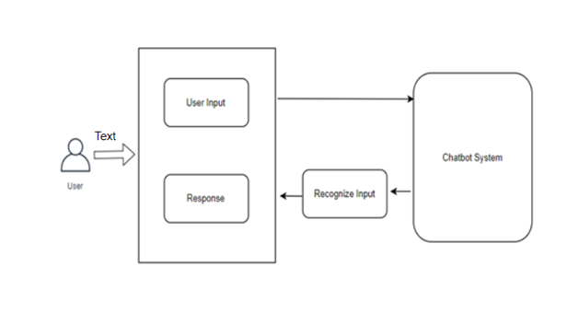

Fig. Conversational Chatbot

In this system user can be able to communicate with chatbot, user give the user input in the form of text and then chatbot system will process that data and give the output in the form of text.

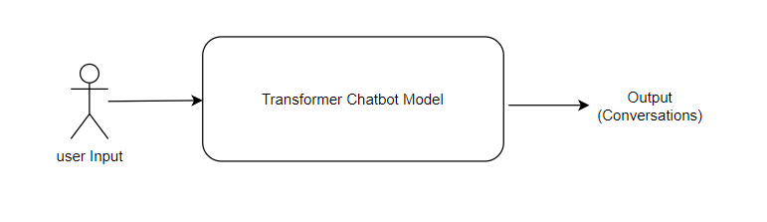

Fig.Chatbot System

User input text data process by the transformer model and give the output in the form of the output text.

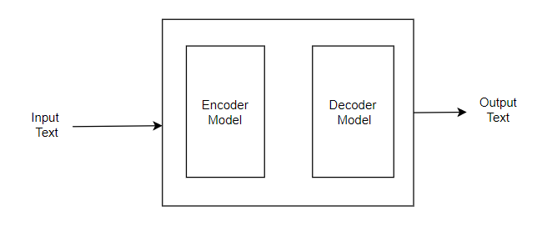

Fig. Transformer

Transformer consist of an encoder and decoder model where encoding and decoding of input data will be done with the help of train data.

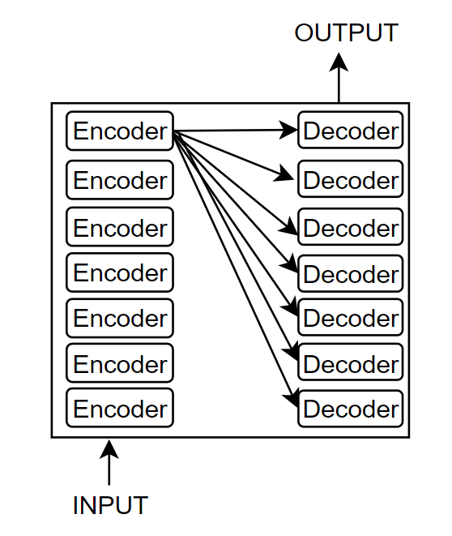

Fig. Encoder Decoder Layer

Each encoder and decoder will contain a series of encoding and decoding layers. In which each encoding layer connected to each decoding layer.

**V. RESULT**

**VI. CONCLUSION**

In this paper wok of conversational chatbot, we started with a brief introduction to chatbot technology. At later stage discussed methods and frameworks that are required

to bringing that idea into practical work.

**REFERENCES**

[1] A. Vichare, A. Gyani, Y. Shrikhande and N. Rathod, "A chatbot system demonstrating Intelligent Behaviour using NLP," in International Journal of Advanced Research in Computer Engineering & Technology (IJARCET), 10 October 2015. J. Clerk Maxwell, A Treatise on Electricity and Magnetism, 3rd ed., vol. 2. Oxford: Clarendon, 1892, pp. 68-73.

[2] R. Shah, S. Lahoti and P. L. K., "An Intelligent Chat-bot using Natural Language Processing," in International Journal of Engineering Research, 1 May 2017. T. L. Gilbert, Formulation, Foundations and Applications of the Phenomenological Theory of Ferromagnetism, Ph.D. dissertation, Illinois Inst. Tech., Chicago, IL, 1956, unpublished.

[3] A. Sordoni, M. Galley, M. Auli, C. Brockett, Y. Ji, M. Mitchell, J.-Y. Nie, J. Gao and B. Dolan, "A Neural Network Approach to Context-Sensitive Generation of Conversational Responses," in arXiv:1506.06714, 22 June 2015.S. O. Demokritov and V. E. Demidov, “Micro-Brillouin light scattering spectroscopy of magnetic nanostructures,” IEEE Trans. Magn.,to be published.

[4] "Contextual chatbots using tensorflow," 2017. [Online]. Available: <https://chatbotsmagazine.com/contextual-chat-bots-with-tensorflow-> 4391749d0077.Y. Yorozu, M. Hirano, K. Oka, and Y. Tagawa, “Electron spectroscopy studies on magneto-optical media and plastic substrate interface,” IEEE Transl. J. Magn. Jpn., vol. 2, pp. 740-741, August 1987 [Dig. 9th Annual Conf. Magn. Jpn., p. 301, 1982].

[5] "Make bots great again," 30 September 2016. [Online]. Available: <http://blog.datatonic.com/2016/09/make-bots-great-again.html>.

[6] "Cornell University Library," 2014. [Online]. Available: https://arxiv.org/ftp/arxiv/papers/1408/1408.6762.pdf.

[7] "Text Classification using Neural Networks," 2017. [Online]. Available: <https://machinelearnings.co/text-classification-using-neural-networksf5cd7b8765c6>.

[8] B.A shawar and E. Atwell, “Evaluation of Chatbot Information System, in Eighth Maghrebian Conference on Software Engineering and Artificial Intelligence.

[9] B.A shawar and E. Atwell, “JLCL,”2007. [Online]. Available: http://www.jlcl.org/2007_heft1/Bayan_Abushawar_and_Eric_Atwell.pdf

[10] B. Setiaji and F. W. Wibowo, "Chatbot Using a Knowledge in Database: Human-to-Machine Conversation Modeling," in Intelligent \ Systems, Modelling and Simulation (ISMS), 2016 7th International Conference on, Bangkok, Thailand.

[11] B. R. Ranoliya, N. Raghuwanshi and S. Singh, "Chatbot for university related FAQs," in Advances in Computing, Communications and Informatics (ICACCI), 2017.